AI ASSIGNMENT

Assignment Information

Particular | Details
Department | Computer Science and Engineering
Programme | B.Tech. / UG Programme
Course Code & Course Name | CSA1717 & Artificial Intelligence
Academic Year / Batch | 2026 – 2027
Faculty Name | Dr. ANOOP M
Assignment Title | AI-Powered Intelligent Route Planning and Path Optimization System
Date of Issue
Date of Submission
Maximum Marks | 100
Course Outcome(s) – CO | CO2, CO4, CO5
Bloom's Taxonomy Level | L4 – Analyze; L5 – Evaluate; L6 – Create
SDG Mapping | SDG 9 – Industry, Innovation, and Infrastructure; SDG 11 – Sustainable Cities and Communities
Industry / Societal Relevance | Smart mobility, intelligent transportation, route optimization and sustainable transport

B. Assignment Problem / Challenge
Develop an AI-Powered Intelligent Route Planning and Path Optimization System that predicts traffic-related route conditions using a Random Forest model and identifies an optimal path between a given source and destination using the A* search algorithm.
- Collect, preprocess, and analyze historical traffic and road-network data.
- Develop and evaluate a Random Forest model to predict traffic congestion or travel time for road segments.
- Represent the transportation network as a weighted graph consisting of nodes and edges.
- Use Random Forest predictions to assign or update the cost of each road segment.
- Apply the A* algorithm to find an efficient path between a given source and destination.
- Evaluate prediction performance and route quality using suitable metrics and test cases.
- Integrate the Random Forest prediction component with the A* path optimization component.
- Discuss efficiency, scalability, privacy, safety, environmental impact, and sustainability.

C. Problem Statement
Urban transportation systems often experience traffic congestion, increasing travel time, fuel consumption, and emissions. Static shortest-path methods may not consider predicted traffic conditions. Therefore, an intelligent route-planning system is required to predict road conditions and use these predictions while selecting a route.
The objective of this assignment is to develop a system in which a Random Forest model predicts traffic congestion or travel time from available traffic-related features. The predicted values are then used as edge costs in a road-network graph. The A* algorithm uses these costs together with a heuristic function to identify an efficient route from the selected source to the destination.

D. Requirements and Constraints
Functional: accept traffic and road data, preprocess the data, predict traffic or travel time, accept source and destination, build a graph, apply A*, and display the recommended route.
AI/ML: implement Random Forest for traffic congestion or travel-time prediction and evaluate it using appropriate metrics.
Search: use A* as the route optimization algorithm and define an appropriate heuristic.
Integration: use Random Forest predictions to determine edge costs for A* search.
Tools: Python, Pandas, NumPy, Scikit-learn, NetworkX, and Matplotlib.
Constraints: dataset quality, availability of real-time data, computation time, graph size, and prediction accuracy.
Safety and Privacy: avoid exposing personally identifiable location information and communicate limitations of route recommendations.
Sustainability: discuss reductions in travel time, fuel consumption, and congestion-related emissions.
E. Student Work

1. Problem Understanding and Formulation
Problem: The system must recommend an efficient route while considering predicted traffic-related conditions. The machine-learning component predicts traffic or travel time, and the AI search component finds the route.
Expected Outcomes:
- A preprocessed traffic and road dataset.
- A trained Random Forest prediction model.
- Predicted traffic congestion or travel time for road segments.
- A weighted road-network graph.
- An A* implementation for optimal path selection.
- A recommended route with total distance, predicted travel time, and route cost.
Available Data: distance, vehicle speed, traffic volume, time of day, day of week, weather conditions, historical traffic indicators, and travel time or congestion labels.
Assumptions: the road network is represented as a graph; road-segment costs are non-negative; the Random Forest model provides predictions for relevant segments; and the heuristic is suitable for A* search.
Constraints: limited historical data, changing traffic conditions, incomplete data, computational limitations, and large road networks.

2. Application of Course Knowledge
This assignment applies Artificial Intelligence and Machine Learning concepts including supervised learning, ensemble methods, graph representation, heuristic search, path optimization, cost functions, and intelligent decision-making.

Random Forest Algorithm
Random Forest is an ensemble machine-learning algorithm that creates multiple decision trees and combines their predictions. It can be used for regression when predicting travel time or for classification when predicting congestion levels.
Possible Input Features:
- Distance of the road segment
- Vehicle speed
- Traffic volume
- Time of day
- Day of week
- Weather conditions
- Historical traffic information
Model Output: predicted travel time, traffic delay, or traffic congestion level.
Working: Traffic Data → Data Preprocessing → Random Forest Training → Multiple Decision Trees → Combined Prediction → Predicted Traffic / Travel Time.

A* Search Algorithm
A* is used to find the optimal path after the road costs are updated using Random Forest predictions.
The A* evaluation function is:
f(n) = g(n) + h(n)
where g(n) is the actual cost from the source to the current node, h(n) is the estimated remaining cost to the destination, and f(n) is the estimated total cost.
A* selects nodes according to the lowest f(n) value and continues until the destination is reached.

3. Solution / Design / Methodology
Step 1: Data Collection. Collect historical traffic and road data containing road segment, distance, speed, traffic volume, time information, weather, and travel time or congestion information.
Step 2: Data Preprocessing. Handle missing values, remove duplicates, encode categorical features, select relevant features, and prepare the data for training and testing.
Step 3: Random Forest Training. Divide the dataset into training and testing sets and train the Random Forest model.
Step 4: Prediction. Use the trained model to predict traffic congestion or travel time for each relevant road segment.
Step 5: Graph Construction. Represent the road network as G = (V, E), where V represents locations/nodes and E represents roads/edges.
Step 6: Edge Cost Assignment. Use Random Forest predictions as edge costs or combine them with distance and travel information.
Step 7: A* Optimization. Provide source and destination, calculate f(n) = g(n) + h(n), explore nodes with minimum estimated cost, and reconstruct the optimal path.
Step 8: Result Display. Display the recommended route, total distance, predicted travel time, and total route cost.
System Flow

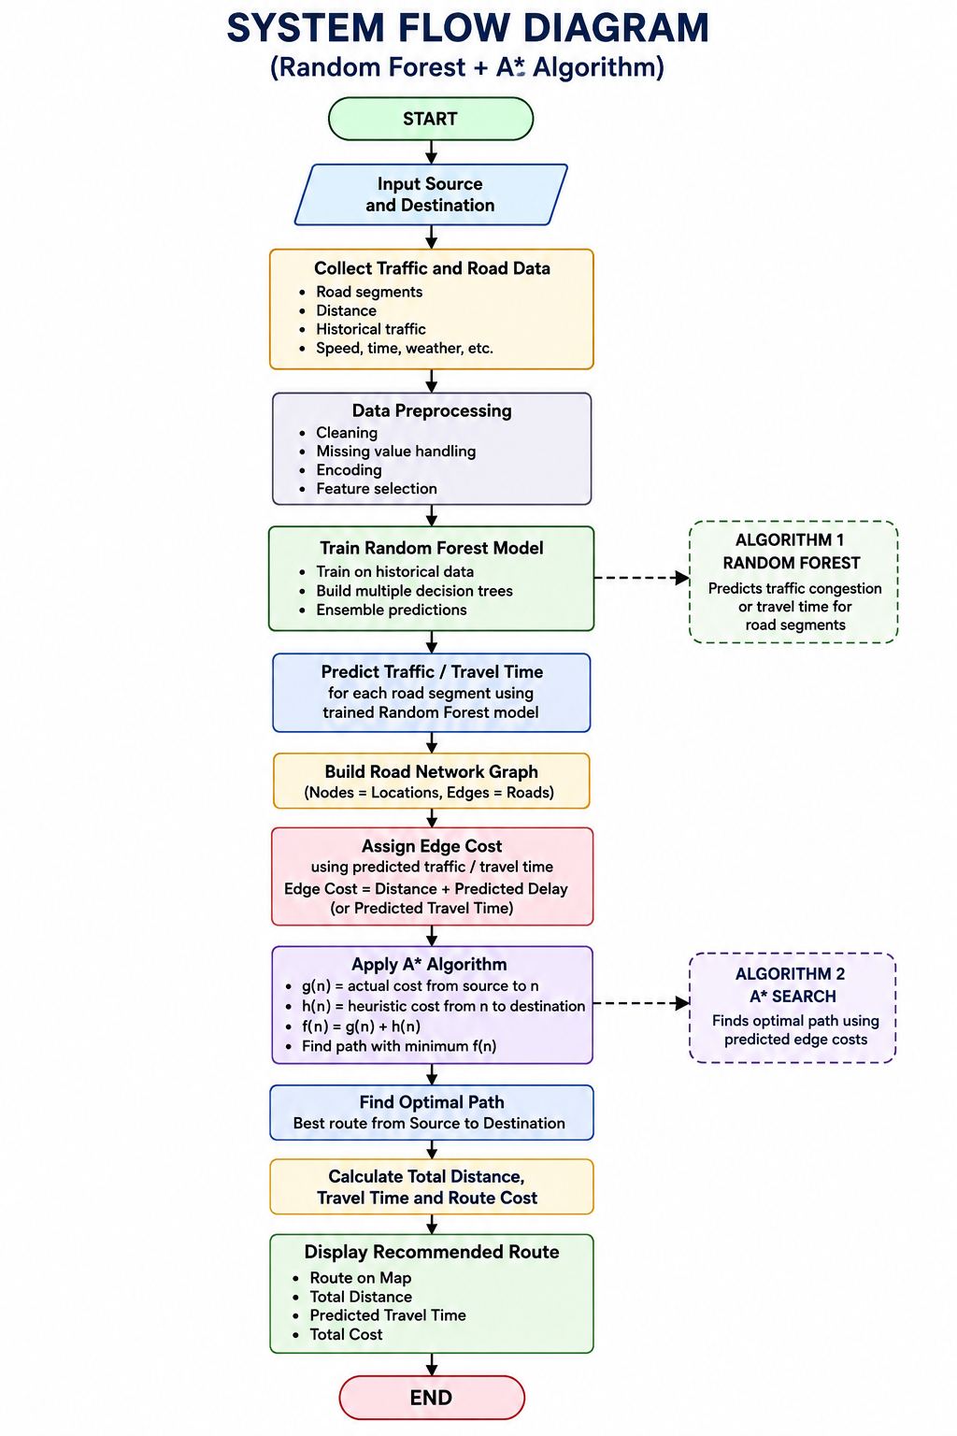

Integration of Random Forest and A*
The Random Forest model and A* algorithm perform different but connected tasks. Random Forest predicts the traffic condition or travel time. These predictions update the cost of each road edge. A* then uses the updated graph to select an efficient path.
Main Integration Flow: Road and Traffic Data → Data Preprocessing → Random Forest Model → Predicted Traffic / Travel Time → Update Road Edge Cost → Road Graph → A* Algorithm → Optimal Route → Display Final Route. Edge Cost Calculation
A simple approach is to use predicted travel time directly as the edge cost:
Edge Cost = Predicted Travel Time
Another approach is:
Edge Cost = Distance Cost + Predicted Traffic Delay

Road Segment | Distance | Predicted Travel Time
A → B | 5 km | 10 min
A → C | 7 km | 8 min
B → D | 6 km | 15 min
C → D | 4 km | 7 min

Example System Architecture

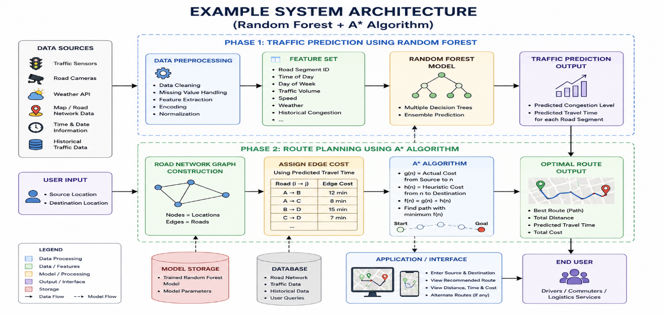

4. Use of Modern Tools
Python: implementation of preprocessing, machine learning, and A* search.
Pandas and NumPy: loading, cleaning, and processing traffic data.
Scikit-learn: training and evaluating the Random Forest model.
NetworkX: graph creation and route-network representation.
Matplotlib: visualization of results and performance.

5. Results and Validation
The system should be validated at two levels: Random Forest prediction performance and A* route optimization performance.
Random Forest Metrics:
- For travel-time regression: MAE, MSE, RMSE, and R² Score.
- For congestion classification: Accuracy, Precision, Recall, and F1 Score.
A* Route Metrics:
- Total route cost
- Total predicted travel time
- Total distance
- Number of explored nodes
- Execution time

Test Case | Source | Destination | Expected Output
1 | A | E | Optimal route and cost
2 | B | E | Optimal route and cost
3 | A | D | Optimal route and cost

6. Analysis and Engineering Decision
Random Forest was selected for prediction because it can model complex relationships between multiple traffic-related features and combines multiple decision trees to improve prediction robustness. It is suitable for predicting traffic congestion or travel time from historical data.
A* was selected for route planning because it combines actual path cost with heuristic information. When an appropriate heuristic is used, it can efficiently search for an optimal path.
Final Decision: Random Forest + A* provides a clear separation of tasks: machine learning predicts road conditions, while heuristic search optimizes the route using those predictions.

Component | Selected Method | Purpose
Traffic Prediction | Random Forest | Predict congestion or travel time
Path Optimization | A* Search | Find optimal path
Integration | Predicted Edge Costs | Use ML prediction in route search

7. Broader Considerations
Sustainability: Better route selection can reduce unnecessary travel time, fuel consumption, and congestion-related emissions.
Environment: Reduced idling and unnecessary travel can contribute to lower pollution.
Society: The system can support commuters, smart-city transportation, delivery services, and other mobility applications.
Safety: The system must not encourage unsafe driving and should acknowledge that real road conditions may change.
Ethics and Privacy: Personal location information should be protected and data should be used responsibly.
Economics: Efficient route planning may reduce fuel and operational costs.

8. Conclusion
The proposed AI-Powered Intelligent Route Planning and Path Optimization System integrates Random Forest and A* to solve an intelligent transportation problem.
Random Forest is used to analyze historical traffic-related information and predict traffic congestion or travel time for road segments. These predictions are used to assign route costs in a weighted road-network graph. The A* algorithm then searches this graph to identify an efficient path from the source to the destination.
The proposed approach demonstrates the integration of Machine Learning with Artificial Intelligence search. The system can provide a recommended route along with relevant information such as predicted travel time, distance, and total route cost.
Limitations: prediction quality depends on data quality; real-time traffic conditions may change; and large road networks may increase processing requirements.
Future Improvements: integrate real-time traffic data, GPS information, weather data, dynamic re-routing, and continuous model updating.

9. Student Reflection
This assignment helped me understand how different Artificial Intelligence techniques can be integrated into a single practical system. I learned how Random Forest can be used to predict traffic-related conditions from historical data and how A* can use cost and heuristic information to find an efficient route.
I also understood that the quality of the final route depends on both the prediction model and the path-search algorithm. If given additional time and resources, I would improve the system by adding real-time traffic information and dynamic route updates.

10. References
- Stuart Russell and Peter Norvig, Artificial Intelligence: A Modern Approach.
- Scikit-learn Documentation – Random Forest.
- Python Documentation.
- NetworkX Documentation.
- Relevant traffic and transportation datasets used for implementation.
- Appropriate software libraries and AI-assisted tools used during development.

F. Common Assessment Rubric

Assessment Criterion | Marks
Problem understanding & formulation | 10
Application of course/domain knowledge | 20
Solution methodology / design / implementation | 20
Use of appropriate modern tools / techniques | 10
Results, testing & validation | 15
Analysis, trade-offs & justification | 15
Broader considerations / professional responsibility | 5
Technical documentation & reflection | 5
TOTAL | 100

G. CO–PO–Assessment Mapping

Assessment Component | CO | PO(s) | Bloom's Level | Marks
Problem formulation | 1,2 | 2 | L3/L4 | 10
Application of knowledge | 2,3,4 | 1,2 | L3/L4 | 20
Solution / Design / Implementation | 2,4,5 | 3,5 | L4/L5/L6 | 20
Modern tool usage | 5 | 5 | L3/L4 | 10
Validation | 4,5 | 4 | L4/L5 | 15
Analysis & justification | 2,4 | 2,4 | L4/L5 | 15
Broader considerations | 5 | 6,7,8 | L4/L5 | 5
Documentation & reflection | 3,4,5 | 10 | L3/L4 | 5

H. Faculty Evaluation & Continuous Improvement

Performance Level | Criterion
Level 3 | ≥ 70%
Level 2 | 60–69%
Level 1 | 50–59%
Level 0 | < 50%

Target CO Attainment: ____________________
Actual CO Attainment: ____________________
Areas in which students performed well: __________________________________________
Areas requiring improvement: _________________________________________________
Corrective / Improvement Action: ______________________________________________
Action to be implemented in the next offering: __________________________________

Documents to be Maintained

- Assignment question/problem statement.
- CO–PO and Bloom's mapping.
- Assessment rubric.
- Student submissions.
- Tool/simulation/experimental evidence, where applicable.
- Evaluated scripts/reports.
- Marks and rubric-wise assessment.
- CO attainment analysis.
- Sample student work representing different performance levels.
- Faculty analysis and continuous-improvement action.

S. NO. | NAME | REG.NO | REFLECTION
1. | AGILAN VIYASH S | 192511346 | I KNOW HOW TO ALANYZE THE PROBLEM, EVALUTE THE SITUATION AND CREATE THE SOLUTION FOR THE PROBLEMS BASED ON ROUTE OPTIMIZATION

